Reflections on the 87th Anniversary of
THE MOLOTOV- RIBBENTROP PACT, AUGUST 23,1939

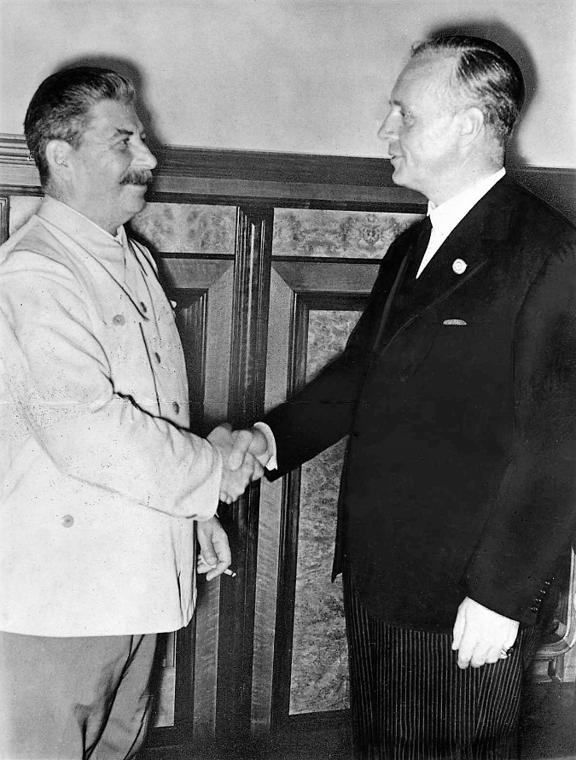
J. Stalin and J. von Ribbentrop, after signing the Nazi-Soviet Pact in Kremlin, Moscow, August 23, 1939 (Bundesarchiv Bild_183-H27337)

The Molotov-Ribbentrop Pact is the name of the treaty signed by the German foreign minister Joachim von Ribbentrop and the Soviet foreign minister Vyacheslav Molotov on August 23, 1939.
Its official name was the Treaty of Non-aggression between the German Third Reich and the Union of Soviet Socialist Republics (USSR), signed on August 23rd late evening in Moscow, and it was the important secret arrangement leading to the start of World War II in Europe. The war claimed between 50 and 80 million lives, including those brutally murdered by both signatories.
In addition to the statement of non-aggression, the treaty had a secret protocol, which was not available for a long time and divided Central and Eastern Europe into two zones of influence – Soviet and German zones. It also divided the territories of Poland, Romania, Lithuania, Latvia, Estonia and Finland. As an immediate result of this treaty, Germany invaded Poland from three directions (west, north and south) on 4:45 a.m. on September 1, 1939. After the Soviet Japanese ceasefire, which started on September 16, the Soviet Union attacked Poland (from the east) early on September 17, 1939. Soon after Finland, and Baltic States were also attacked by Soviets.

On November 30, Soviet troops attacked Finland along its entire eastern border starting the Winter War of 1939-1940. The Molotov-Ribbentrop Pact ended the European order established by the Treaty of Versailles in 1919 after WWI. It had a direct impact on the Second World War, the division of Europe, and the subsequent Cold War, and starting misery and death from the communist oppression lasting in some nations for a half of the century.
The bloody war in Ukraine, and the violation of human rights in Belarus, are clear reminders that Putin and Lukashenko follow in the footsteps of the USSR. Putin’s Russia makes use of the brutal force and manipulation of historical facts to rebuild of influence lost in 1989 with the collapse of the USSR and the fall of the Berlin’s Wall.
Every year on August 23, Canada observes officially the Black Ribbon Day to commemorate the victims of Hitler's Germany and Stalin's Russia, two brutal totalitarian regimes.

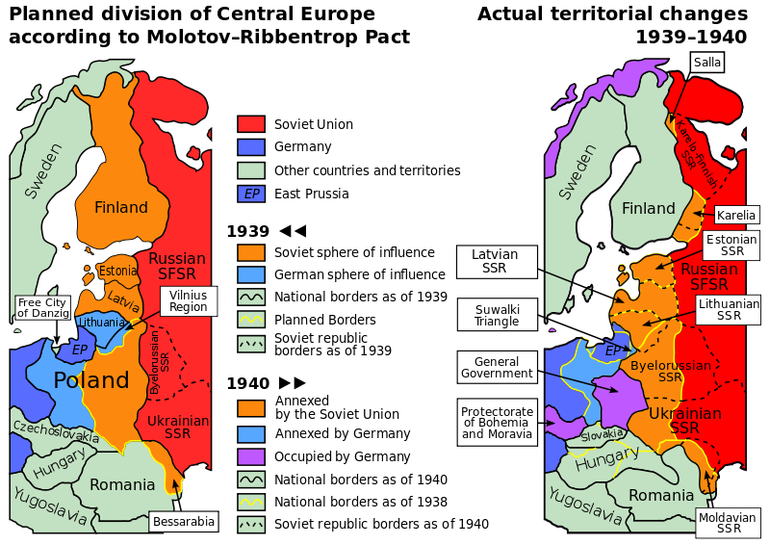
Planned and actual changes of territories 1939 – 1940 as the result of the Molotov-Ribbentrop Pact
(Public Domain)

Lest We Forget

