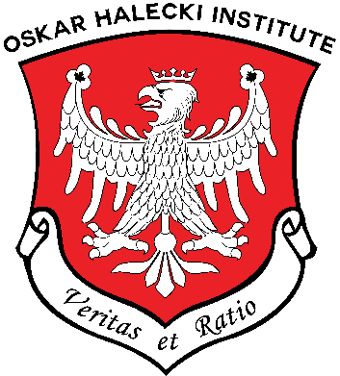
ANNOUNCEMENT # 28
OSKAR HALECKI INSTITUTE IN CANADA (OHI)
25th of July 2026
DR. JOHN LENCZOWSKI, PH.D.
NOMINATED AN HONORARY MEMBER
OF THE OSKAR HALECKI INSTITUTE IN CANADA

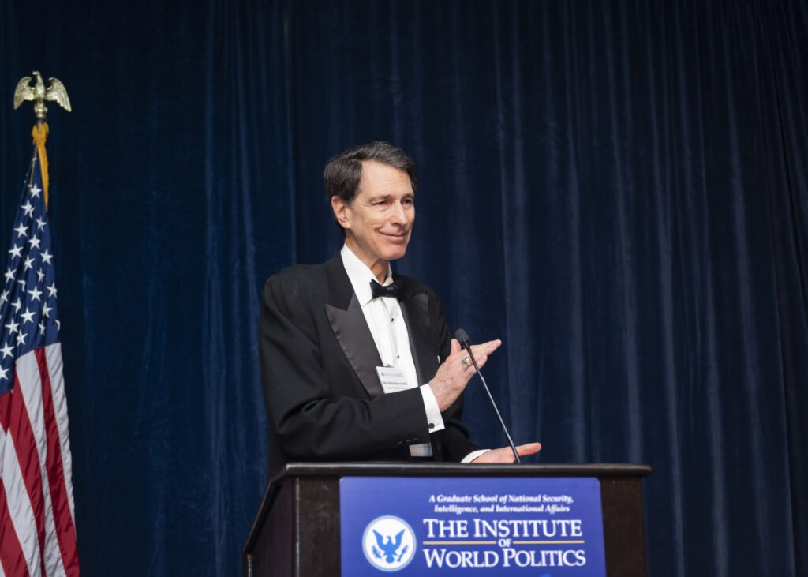
Dr. John Lenczowski, Founder, President Emeritus and Chancellor,
Institute of World Politics, Washington, D.C.
(Photo by Aesthetic Images Photography,
Special Evening to honor Dr. J. Lenczowski, May 9, 2024).

Dr. John Lenczowski is Founder, President Emeritus and Chancellor of the Institute of World Politics (IWP) in Washington, D.C. He was an exceptional member of the Security Council during Ronald Reagan’s administration serving America with expectational dignity and wisdom. He built the unique Graduate School of statecraft, security, intelligence, and international affairs. The graduate school was founded in 1990 and offers unique cross-section of courses related to intelligence, national security, diplomacy and international affairs in the American national capital to train students how to apply all very difficult instruments of statecraft but grounded in American founding principles and the rule of international law. The IWP was affiliated between 1991 – 2005 to Boston University. Since then, the IWP attained the independent accreditation by the Middle States Commission on Higher Education and is licensed to operate in Washington, D. C. The IWP offered the Doctor of Statecraft and National Security (DSNS), which is a degree targeted towards those who wish to pursue national security careers, as opposed to academic teaching. The Institute is a non-profit and tax-exempt educational institution, relying on private charitable donation and tuition. The Institute houses the Kosciuszko Chair of Polish Studies, the Center for Culture and Security, and the Center for Energy Security and Diplomacy.
The Board of Directors of the Oskar Halecki Institute in Canada nominated Dr. John Lenczowski unanimously as an Honorary Member of the Institute on June 23, 2026.
Dr John Lenczowski had supported our Institute in Canada from its beginning in 2013-2014. He visited Ottawa several times and he was a distinguished speaker at the Second Biennial Lecture of the Polish Institute of Arts and Sciences in Canada on February 11, 2011, at Saint Paul University. His lecture was titled Poland, the Principles of Liberty, and the Defense of Western Civilization. Later his testimony on the horror of communism helped in establishment of the Monument of Victims of Communism in Ottawa, Canadian national capital (as its original project and site).
On behalf of the Board of Directors and my own I would like to wish a continued success to Dr. John Lenczowski, an exemplary American patriot, and believer and warrior for Western Civilization. I am honored to know him as a friend of Poland, especially in this year of 250. Anniversary of the American Constitution. I wish Dr. Lenczowski, health and everything the best and continued contributions to America, the heart of Freedom of the World and to the Institute of World Politics.

Dr. Alexander M. Jablonski, Ph.D., P.Eng.
President, The Oskar Halecki Institute in Canada

Dr. John Lenczowski, Ph.D., Founder, President Emeritus, and Chancellor of the unique institution The Institute of World Politics (IWP), was born July 20, 1950, in Hamilton, New York. He is a son of late Professor George (Jerzy) Lenczowski, a lawyer, diplomat scholar and Professor of the University of California at Berkely, a known specialist of the Middle East, and Bronisława Szyłkiewicz. His late father, Professor George (Jerzy) Lenczowski personally knew Prof. Oskar Halecki and valued his works.
He founded and built the unique graduate school of national security, intelligence, and international affairs in Washington, D.C. in 1990. The KoThe Institute of World Politics offers seven master’s degrees including the nation’s first MA program outside the U.S. government in strategic intelligence, and the nations’ first professional Doctorate in Statecraft and National Security (DSNS). Dr, Lenczowski attended the Thacher School, earned his. B.A., at the University of California, Berkely, and received his M. A. and Ph.D. from the John Hopkins University School of Advanced International Studies, Baltimore, MA.
From 1979 to 1981 he served on the staff of Congressman James A. Courter. From 1981 to 1983, he served in the State Department in the Bureau of European Affairs and as a Special Advisor to Under Secretary for Political Affairs, Lawrence Eagleburger. From 1983 to 1987, he was Director of European and Soviet Affairs at the National Security Council and in the capacity, he served as principal Soviet affairs adviser to President Ronal Reagan. From 1987 to 1989, he served as a consultant to the State Department’s Bureau of Human Rights and Humanitarian Affairs.
He has worked also in a number of academic and research institutions in the Washington area including Georgtown University (where he taught 15 years on a part-time basis), the University of Maryland, the American Enterprise Institute, the Ethics and Public Policy Center, The Council of Inter-American Security, and the International Freedom Foundation.
He is the author of Soviet Perceptions of U.S, Foreign Policy – A Study of Ideology, Power and Consensus (1982); The Sources of Soviet Perestroika (1990); A Multi-faceted Strategic Asset of Soviet Power (1991); Full-Spectrum Diplomacy and Grand Strategy – Reforming the Structure and Culture of U.S. Foreign Policy (2011) and numerous other writings and addresses on U.S. foreign policy, public diplomacy, cultural diplomacy, counter-propaganda, political warfare, Soviet/Russian affairs, comparative ideologies, intelligence, strategic deception, counterintelligence, and integrated strategy. In recent years, he has focused intensively on Communist China (strategic influence operations, and U.S. national security policy toward China).
In his remarks, John Lovewell, who served on the IWP’s Board of Trustees since 2005, said in his address in 2024 during a special evening to honor Dr. John Lenczowski:
Dr. Lenczowski is one of the unsung Great Men of Our Time. In my view, the greatest statesmen of the last 100 years include FDR, Winston Churchill, Margaret Thatcher, Pope Joan Paul ii, and Ronald Reagan for their vision and courage and ability to change the course of events in defense of Western Civilization. Each of these giants had lieutenants and advisors who shared their vision and participated in the development of strategy and policy, often brilliantly. For example, FDR had the great General George Marshall to anticipate the threats posed by the Axis in WW11 and orchestrate the leadership of a vast military across the globe.
Like a George Marshall to Reagan, John was one of the most important members of the Reagan family team for his ability to understand the threat posed by the Soviet Union and devise strategies to defeat it. John often swam against the tide of public and professional opinion, even within the Reagan administration. He asked for no recognition and labored with national security leadership and other compatriots to establish the policies and strategies which ultimately defeated the Soviet Union, all without firing a shot.
It is an impossible task finding better characterization of the most important contribution of Dr. John Lenczowski to America, to the freedom of our Western Civilization and to all of us.
We are honoured having him as a member of our Program Council, The Oskar Halecki Institute in Canada.
Prepared by AMJ

