THE MOLOTOV-RIBBENTROP PACT

of AUGUST 23, 1939

Reflections on the 86th ANNIVERSARY of the agreement between the Nazis and the Soviets

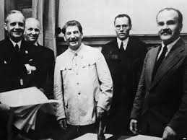

J. v. Ribbentrop, J. Stalin and V. Molotov after signing the Nazi-Soviet

Non-aggression Pact in Kremlin, Moscow, 23 August 1939 (Wikipedia)

The Molotov-Ribbentrop Pact is the informal name of a treaty signed by German foreign minister Joachim von Ribbentrop and Soviet foreign minister Vyacheslav Molotov. Officially it was the Treaty of Non-aggression between the German Third Reich and the Union of Soviet Socialist Republics (USSR), and was signed in Moscow in the late evening of August 23, 1939. It constituted the most important secret arrangement leading to the start of World War II, a war which claimed between 50 and 80 million lives (including those brutally murdered by both signatories). In addition to the statement of non-aggression, the treaty included a secret protocol, which was not known for a long time. It divided Central and Eastern Europe into two zones of influence - Soviet and Nazi German zones. The secret protocol divided the territories of Poland, Romania, Lithuania, Latvia, Estonia, and Finland. As an immediate result of this treaty, Germany invaded Poland from three directions (west, north and south) on September 1, 1939. After the Soviet-Japanese ceasefire, which started on September 16, Stalin's Russia also invaded Poland (from the East) on September 17, 1939.

Of the Polish territories annexed by the Soviet Union in 1939-1940, the region around the city of Białystok and a small part of the territories east of the river San around the city of Przemyśl are part of present-day Poland. The Soviet military continued to keep an occupational presence in Poland until 1993. All other territories annexed by the Soviet Union between 1939 and 1940 from those countries that regained their independence after the collapse of the Soviet Union in 1991, remain part of the Russian Federation, the successor state of the USSR. The annexed territories include Karelia and the Northern region of Petsamo (taken from Finland), the area of Ingrian and the County of Petseri (taken from Estonia), and the Abrene region (taken from Latvia). Three other territories, northern Bukovina, southern Bessarabia, and the region of Hertza are now part of Ukraine, which became an independent state in 1991.

The Molotov-Ribbentrop Pact brought to an end, the Europe that had taken shape after the Treaty of Versailles in 1919. It had a direct impact on the start of the Second World War, the division of Europe, and the subsequent Cold War.

The Ukrainian-Russian war, which started with annexation of Crimea in 2015, and the full Russian invasion in 2022, is a chilling reminder that Putin's Russia follows in the footsteps of the USSR. It brought death, despair and violation of human rights to millions. Putin’s Russia makes use of manipulation and brutal force, and constantly desires to dominate its neighbours by breaking international law. The world, including Europe, is waiting for a peaceful resolution.

Every year on August 23, Canada observes Black Ribbon Day to commemorate the victims of Hitler's Germany and Stalin's Russia, two nakedly totalitarian regimes.

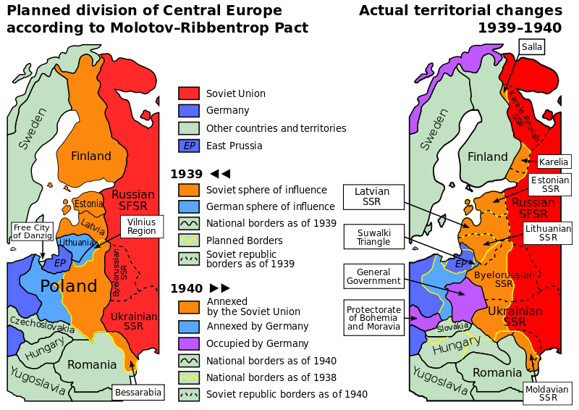

Planned and actual changes of territories in 1939–1940-time frame (Public domain)