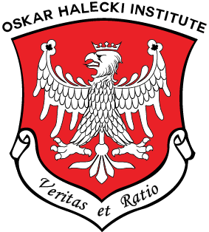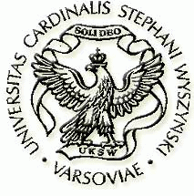
OSKAR HALECKI INSTITUTE IN CANADA (OHI) &
CARDINAL STEFAN WYSZYŃSKI UNIVERSITY (USKW) IN WARSAW

Cordially Invites You to

THE 5th OSKAR HALECKI SYMPOSIUM
on the occasion of 10th Anniversary of OHI

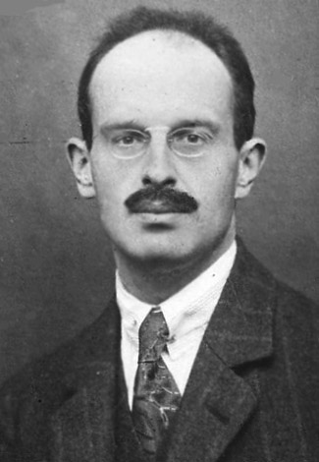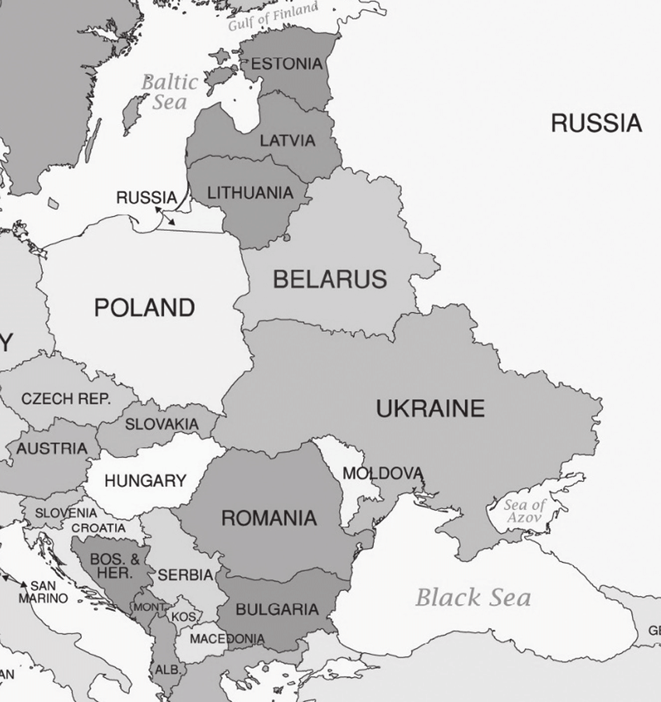

Evolution of the Central Eastern Europe – New Challenges
25-26 October 2024, Ottawa, Ontario, Canada

Amphitheatre G1124, Saint Paul University, 223 Main Street, Ottawa, ON K1S 1C4
25 October, Friday 7:00 p.m. – 9:30 p.m.
Opening Session, two Keynote Lectures (Prof. M. J. Chodakiewicz, Prof. M. Kornat), Reception
Exposition of posters from Institute’s events

26 October, Saturday 8:00 a.m. – 2:00 p.m.
Keynote Lecture (Brig.-Gen. (Ret’d) R. Williams, Panels, Lunch, Closing Session with Presentation of the Oskar Halecki Medal
Distinguished Speakers from Poland, USA and Canada

Symposium registration fee: $60., students and seniors: $30. (coffee and lunch included)
To register, please fill out the attached registration form

Contacts: Anna Minkiewicz-Janda Tel. (613) 793-7405, E-mail: aminkiewicz.janda@gmail.com
Alexander M. Jablonski Tel. (613) 277-0086, E-mail: alexstarza@gmail.com

THE 5TH OSKAR HALECKI INSTITUTE SYMPOSIUM
October 25-26, 2024
OTTAWA, ONTARIO, CANADA

REGISTRATION FORM

Name and Title :......................................................................................................................

Affiliation: .............................................................................................................................

Address: ................................................................................................................................

Tel. and E-mail:......................................................................................................................

Number of registrations for the Symposium on October 25-26, 2024
...... x $60. = $……; ….. x $30. (students and seniors) = $........

Gift donation to Oskar Halecki Institute (tax receipts will be issued for donations above $50.) $.........
See a note below.

TOTAL: $...........
Please send your registration form and a cheque issued to The Oskar Halecki Institute
to our Treasurer, Mrs. Anna Minkiewicz-Janda – 764 Maloja Way, Stittsville, ON K2S 0N7.
Payment can be made also using e-Transfer using e-mail: aminkiewicz.janda@gmail.com, directly to our account.

Gift donations are welcome and for larger than $50. please issue a cheque for Ruebenbauer Foundation
and send it to the same address (with a note – for the Oskar Halecki Institute).

Attendance badges will be available at Registration Desk on October 25-26, 2024 .

Contacts: Anna Minkiewicz-Janda Tel. (613) 793-7405, E-mail: aminkiewicz.janda@gmail.com
Alexander M. Jablonski Tel. (613) 277-0086, E-mail: alexstarza@gmail.com

